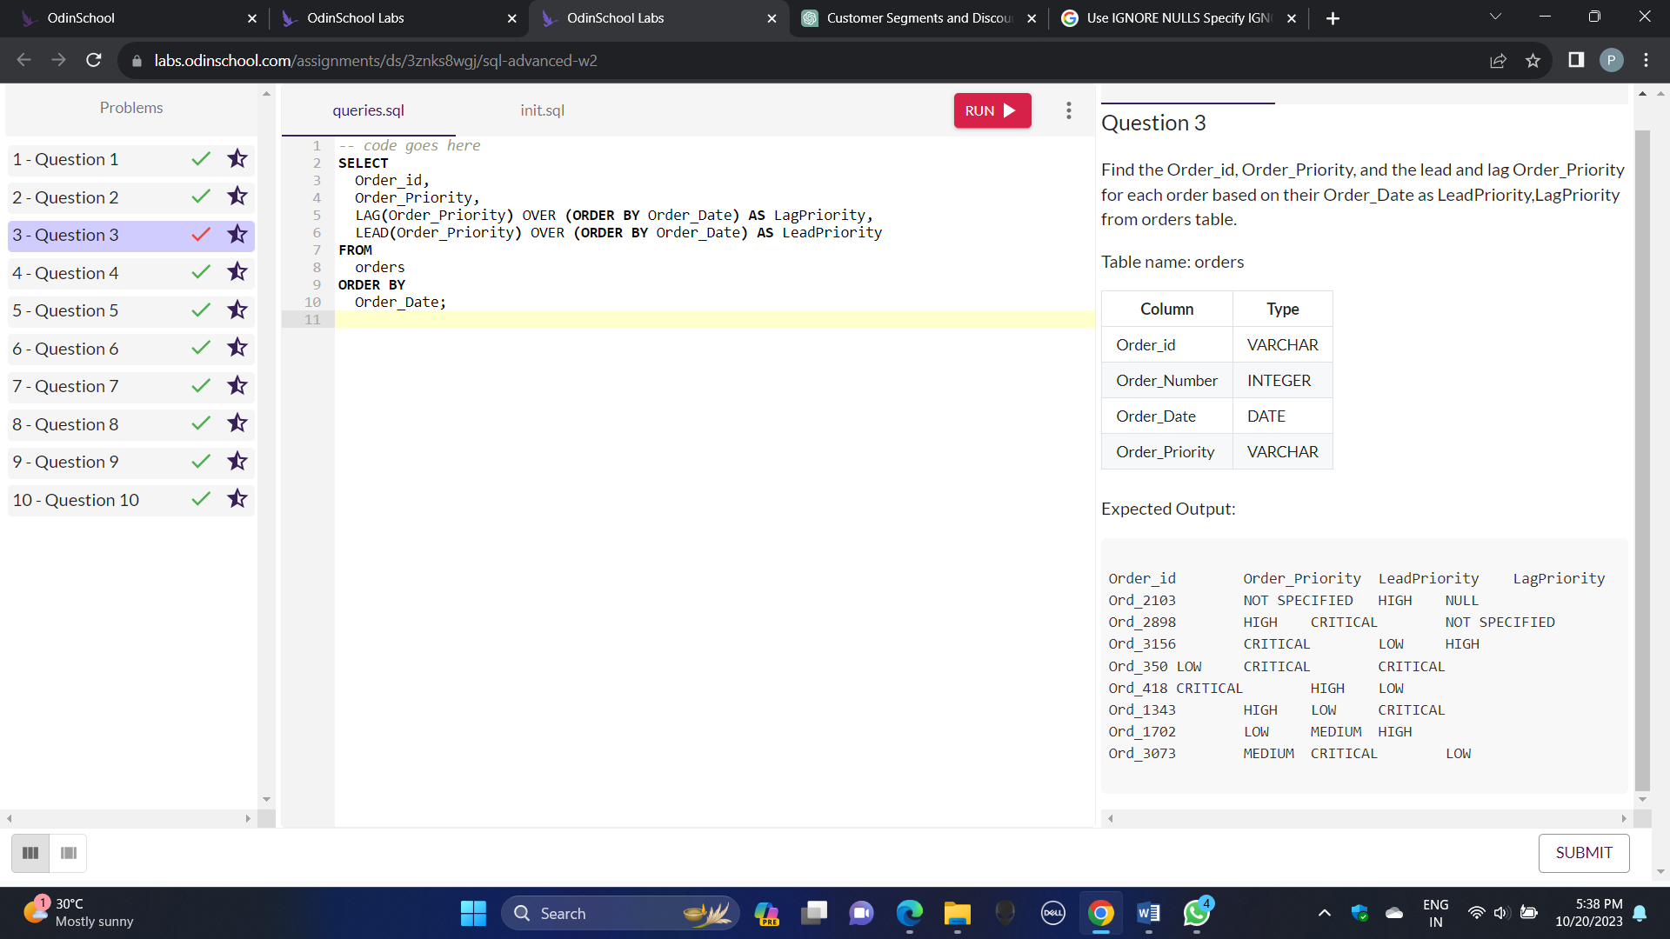MY QUERY:

SELECT

Order_id,

Order_Priority,

LAG(Order_Priority) OVER (ORDER BY Order_Date) AS LagPriority,

LEAD(Order_Priority) OVER (ORDER BY Order_Date) AS LeadPriority

FROM

orders

ORDER BY

Order_Date;

.

**My query giving error when I submitted this query what should be the query to get exact answer help me out**